Product Presentation

1. Overview of the system

The Flight Management System consists of four subsystems: Reservation Subsystem, Profile Subsystem, Service Subsystem, and Report Subsystem to manager all flights reservations, user profiles, in-flight services and generate all kinds of reports.

There are 4 user groups in this system:

General Public (Unregistered-Customer, Registered-Customer, Agency)

Staff

Flight Manager

Service Manager

System Admin

1. Basic Functionalities

2.1 User login

This part provides a way for all system users to access the system functionalities, when login as a Customer and Agency, you need to provide your email as user name and password. If login as any kind of Staff user (System Admin, Flight Manager, Service Manager, Staff), you need to provide your username and password.

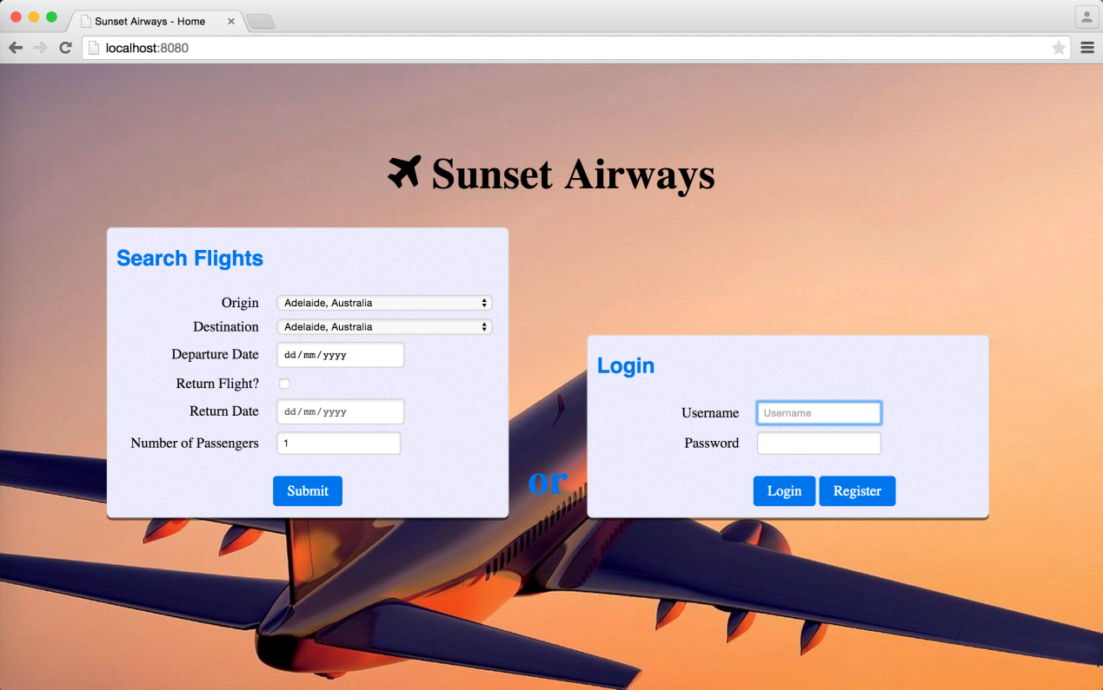

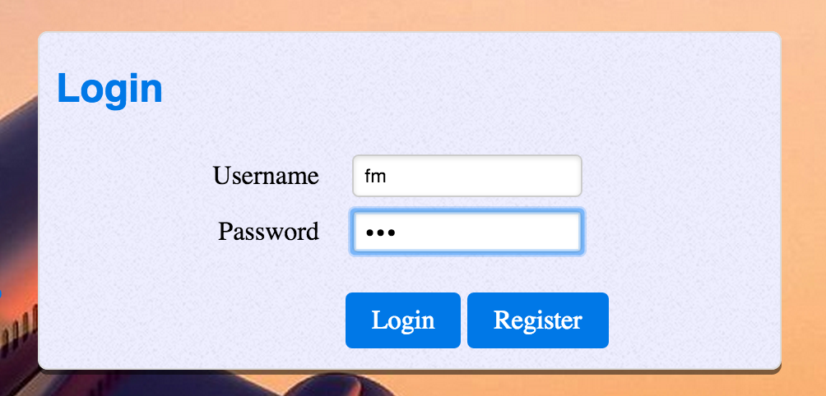

If the password is incorrect, an error message will be displayed.

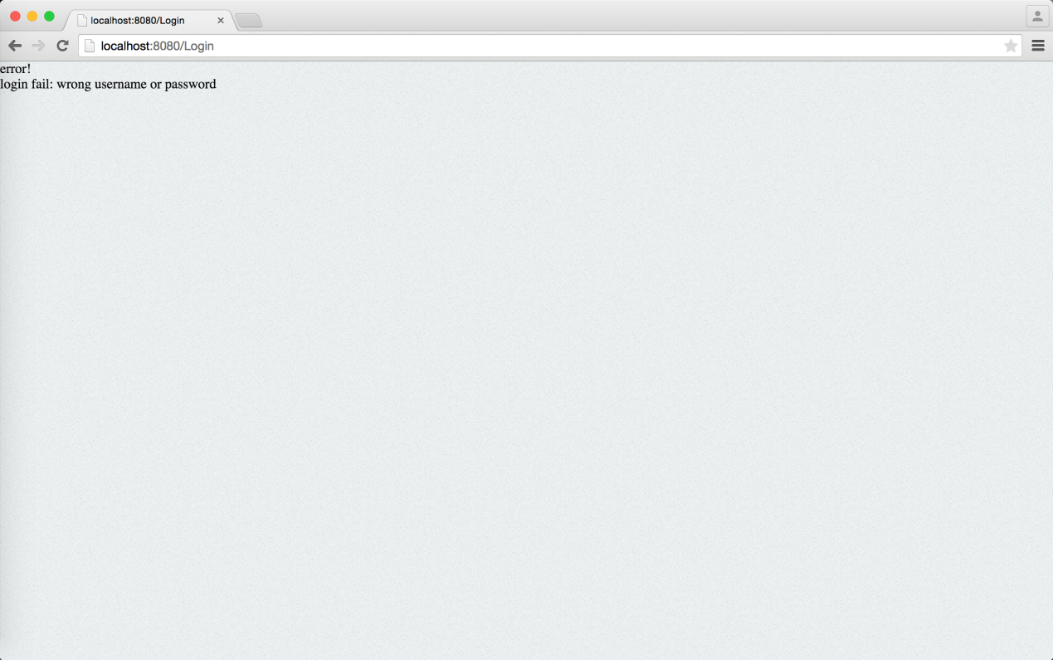

2.2 User logout

After you have finished all your work in the system, you can logout the system at any time, just click on the Logout button when you want to log out.



When login success the home page of the system will display

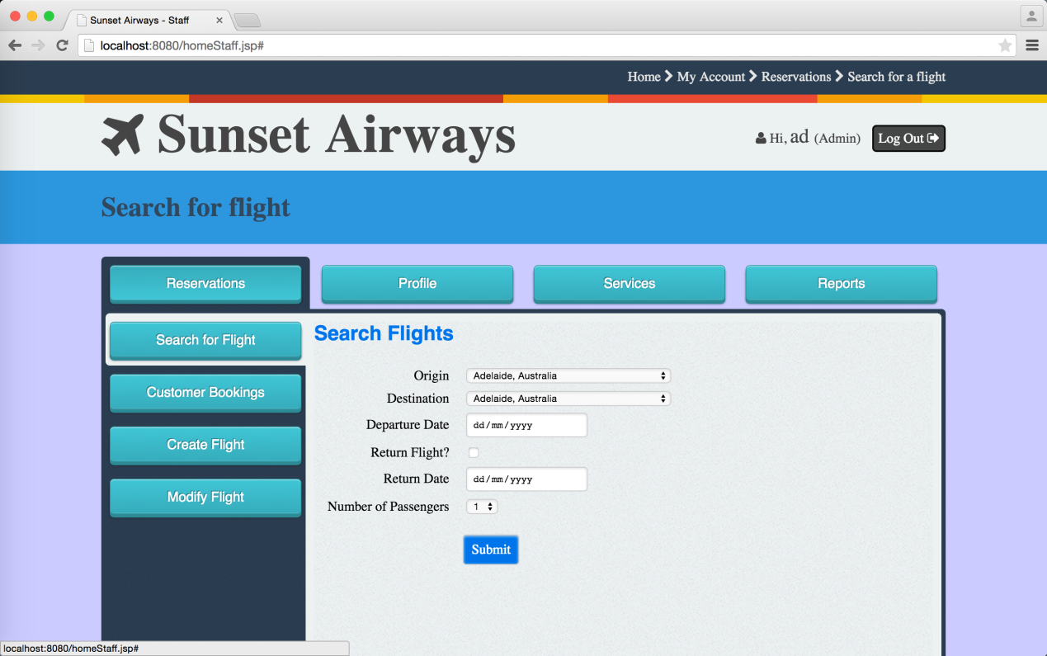

1. Reservation Subsystem Functionalities

This section captures the functionalities that the Flight Management System provides to all users (System Admin, Flight Manager, Service Manager, Staff, Registered- customer, Unregistered-customer, Agency) manages (e.g. add, change, and modify) all flight reservations, seat selection, ticketing, flight availability, flight details, rates and conditions.

* 1. Flight Manager can create a new fight schedule.

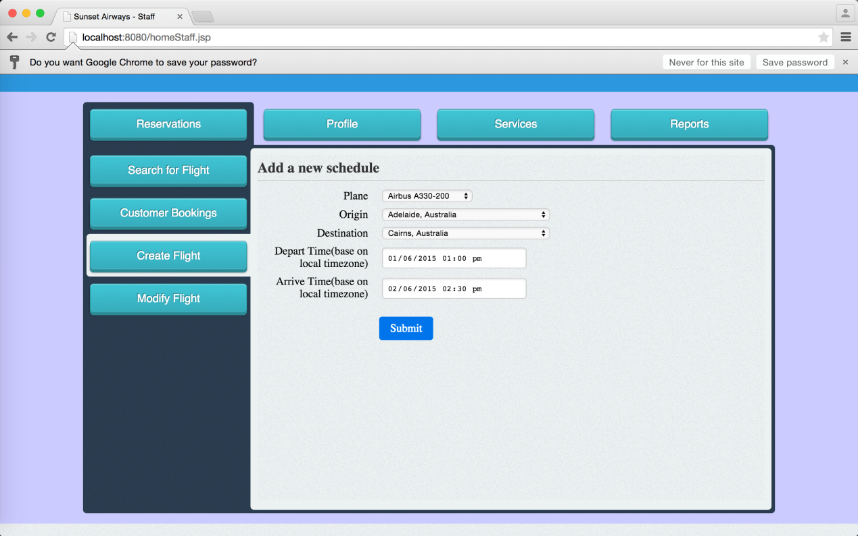

When finish all the selection and click the submit button, the new flight schedule will be created successfully and the flight ID will be generate automatically.

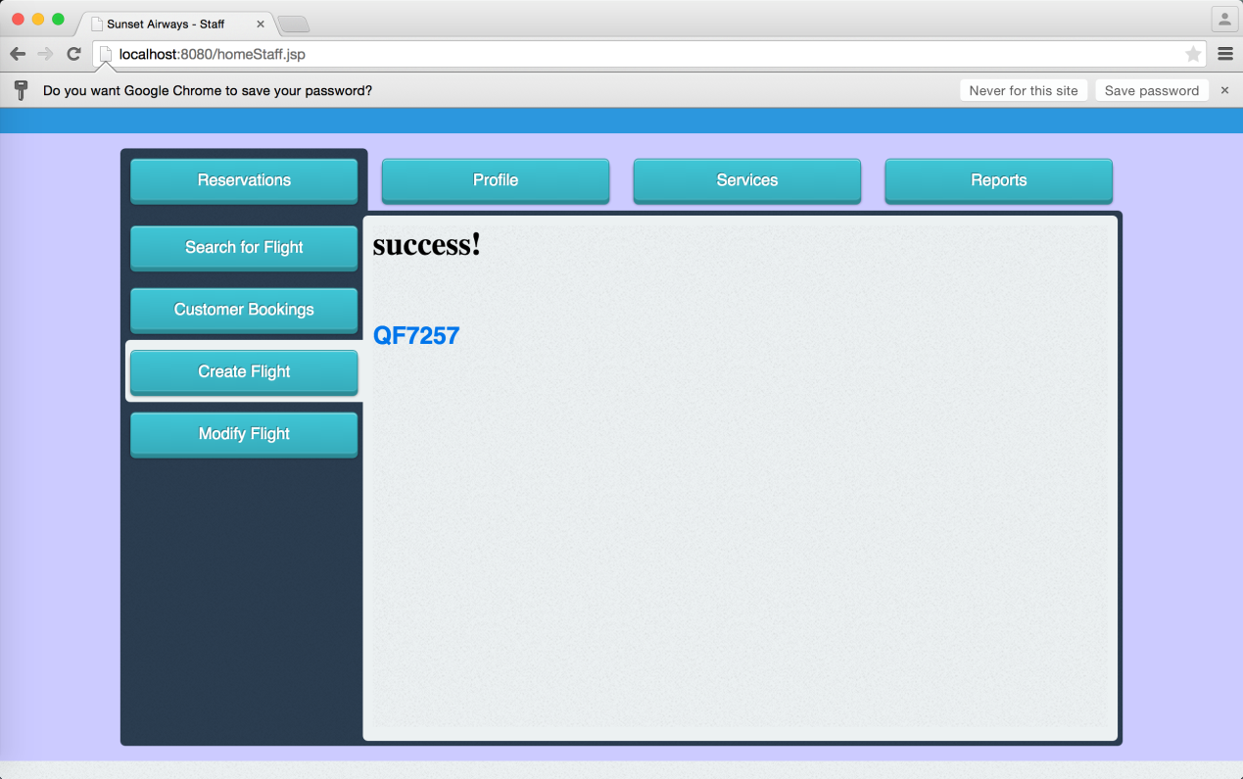

* 1. Flight Manager can also modify an existed flight schedule by input the origin and destination of the flight.

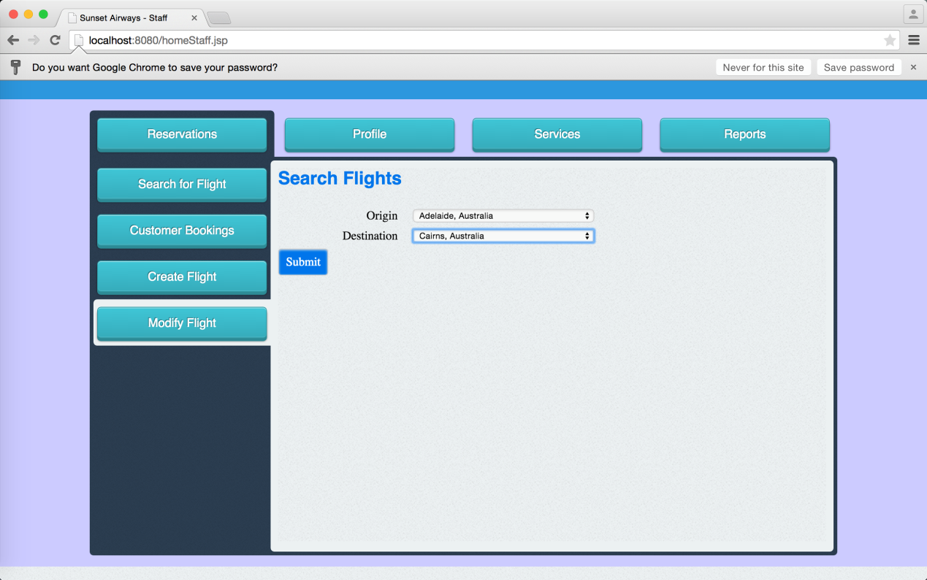

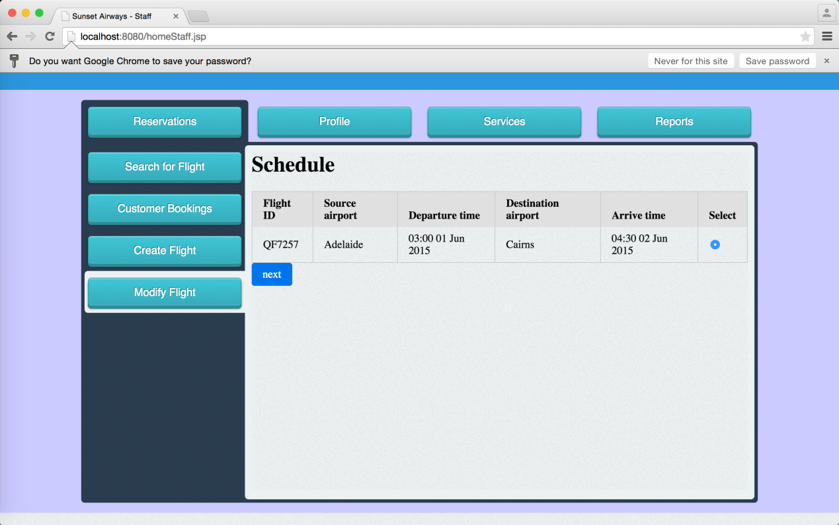

Choose the thing you want to modify

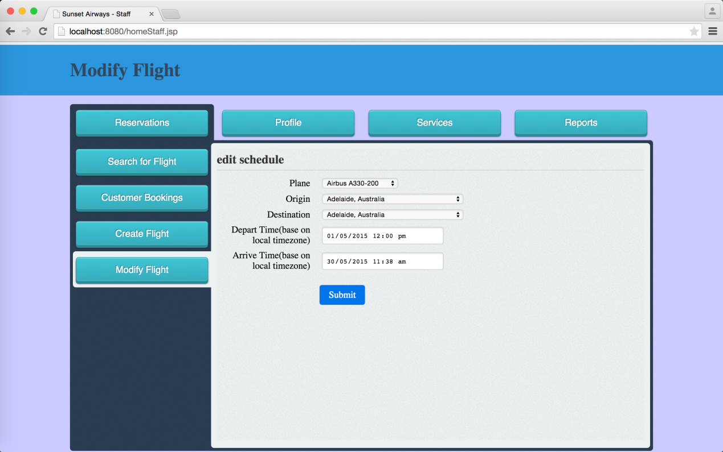

And click the submit button

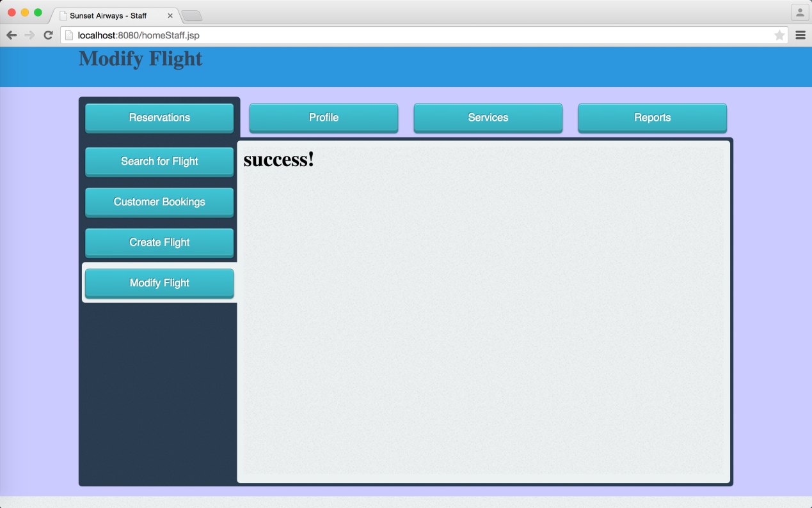

All kinds of system user can search flights

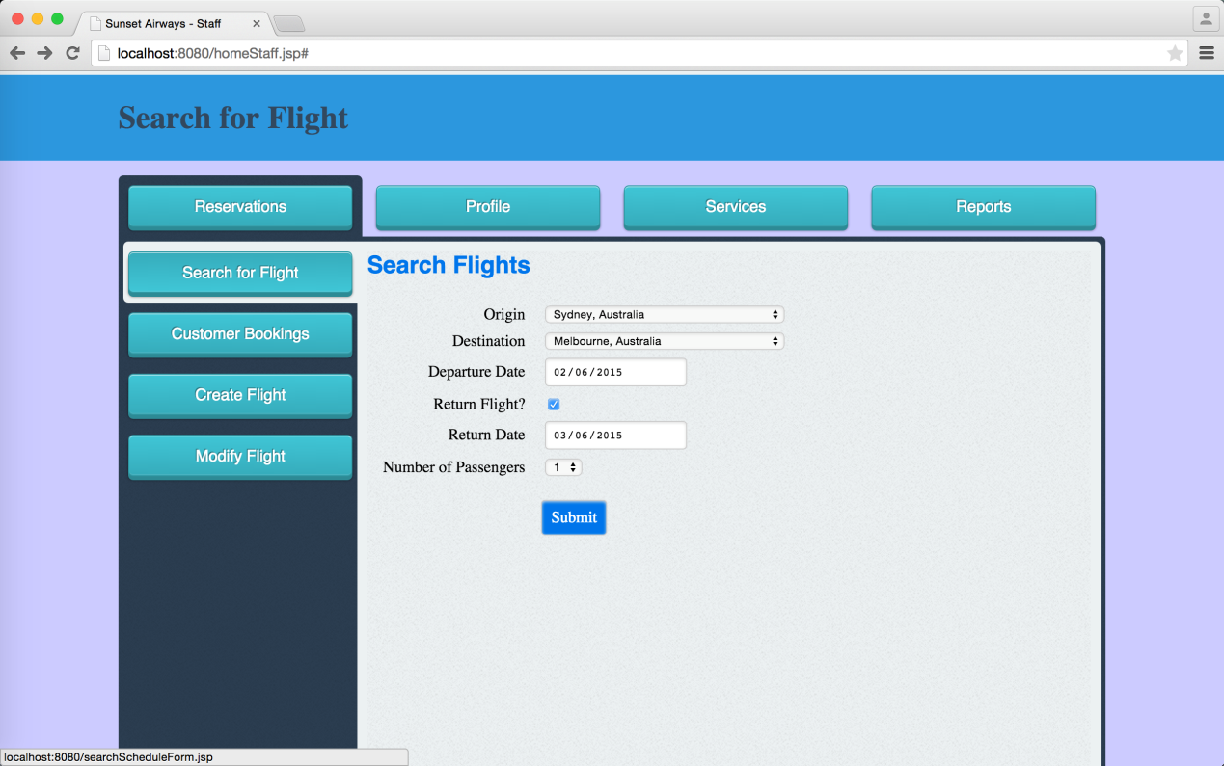

When finish all the selection and submit the request, the flight list will display

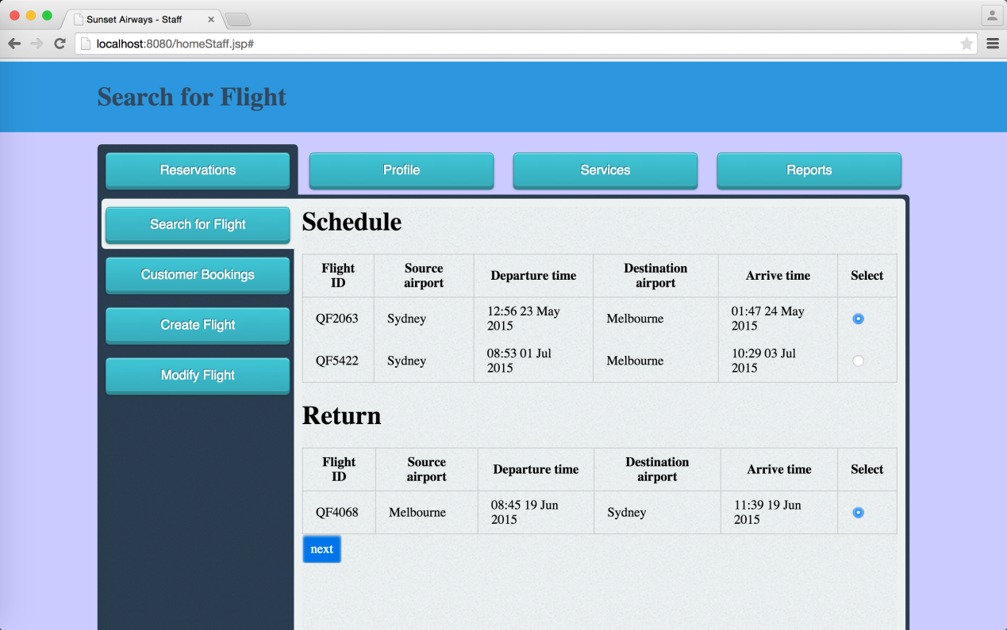

3.3 Customer can make a flight booking

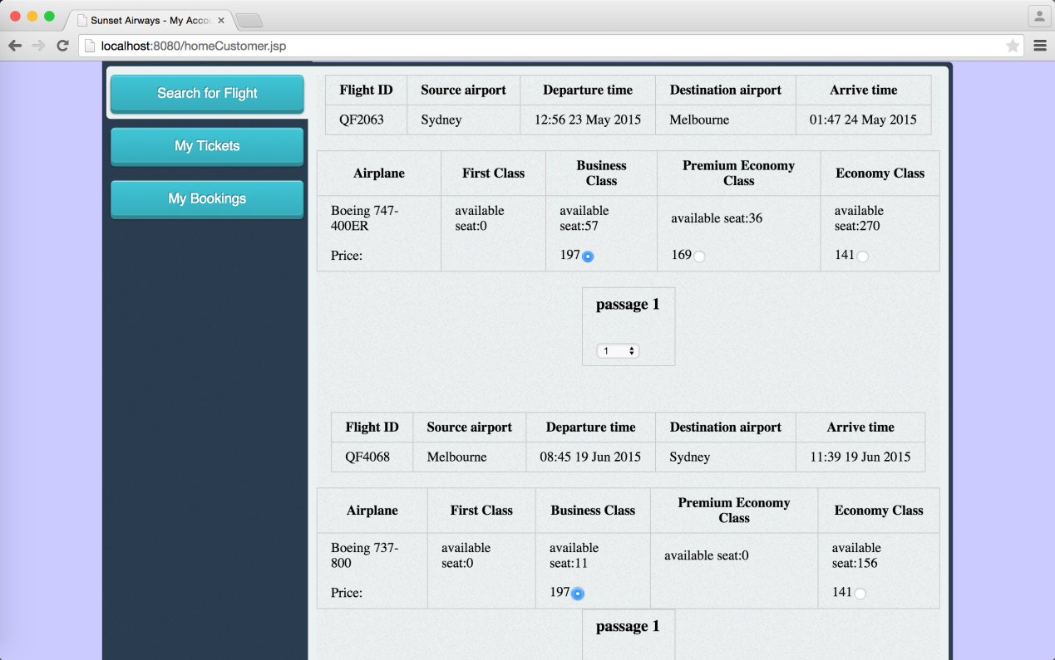

Enter email of passage

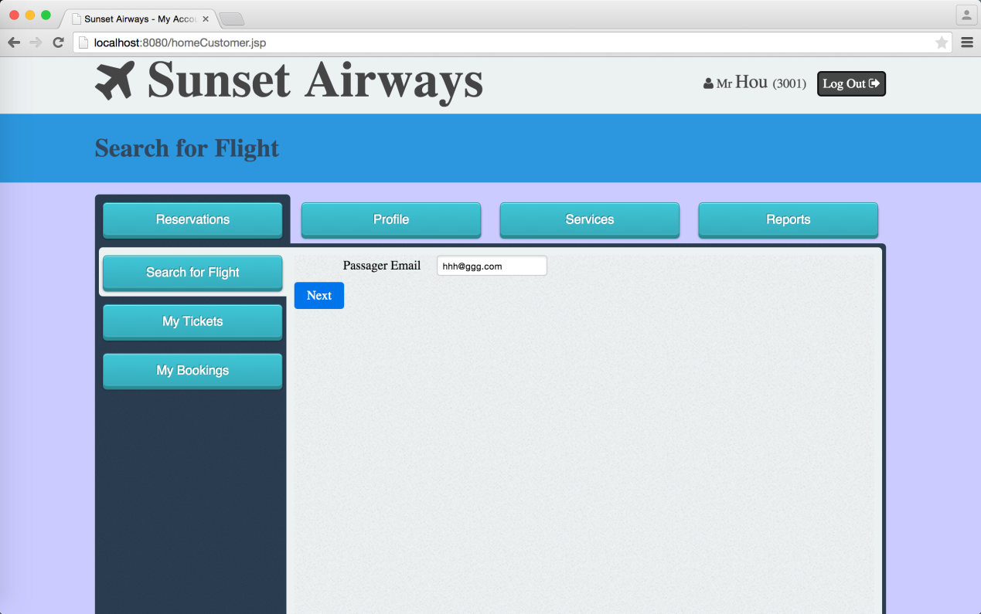

* 1. When an Unregistered-Customer wants to make a flight, they need to register a user account in the system.

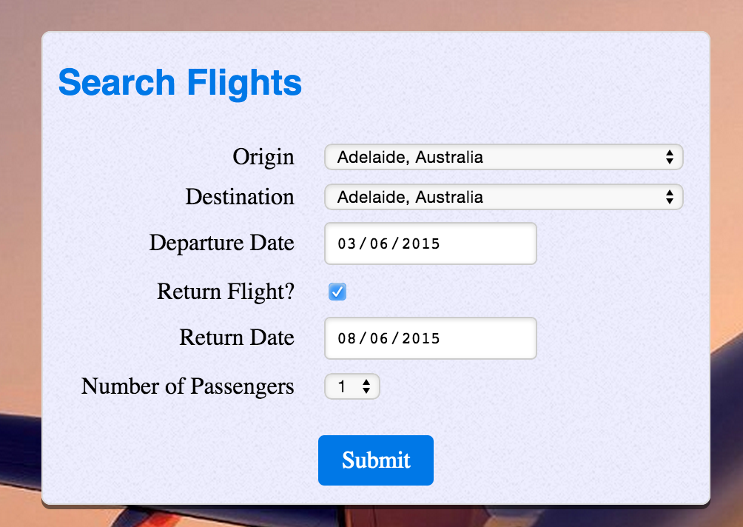 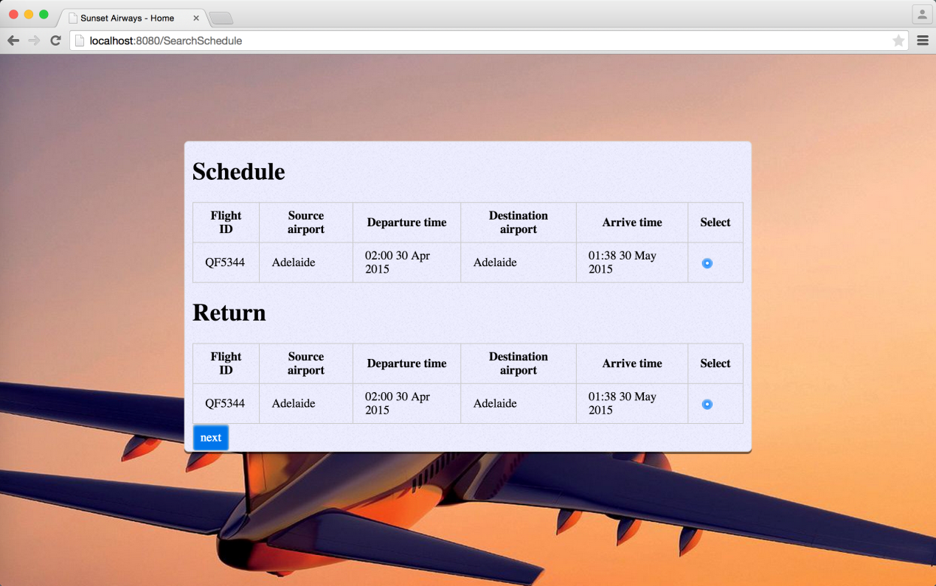

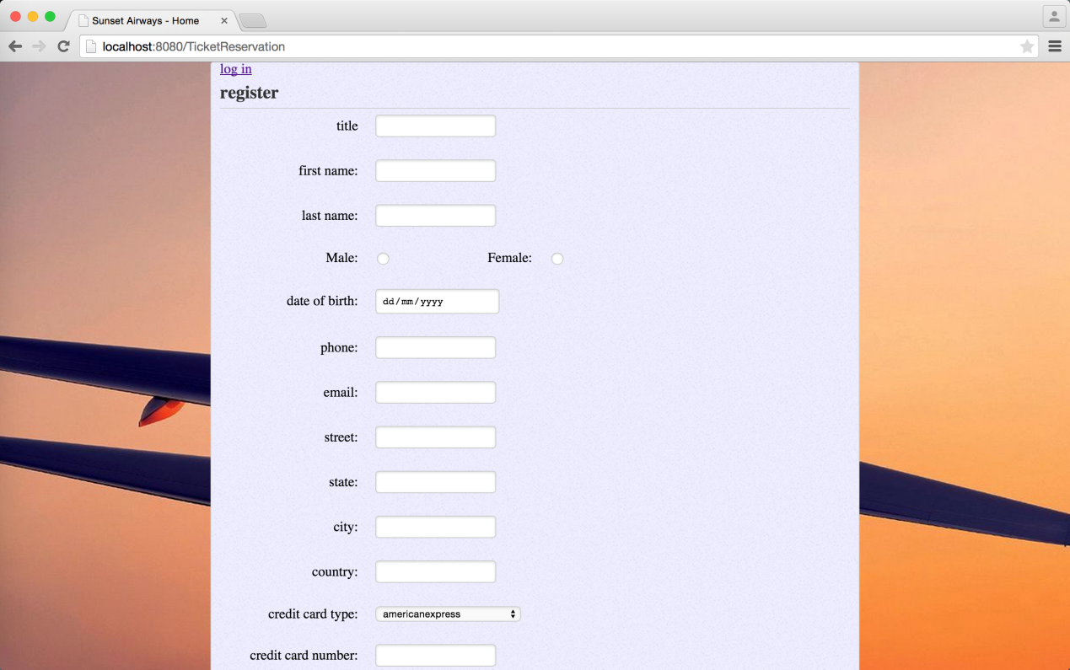

* 1. Staff can make a flight booking for customer by provide the email of the customer.

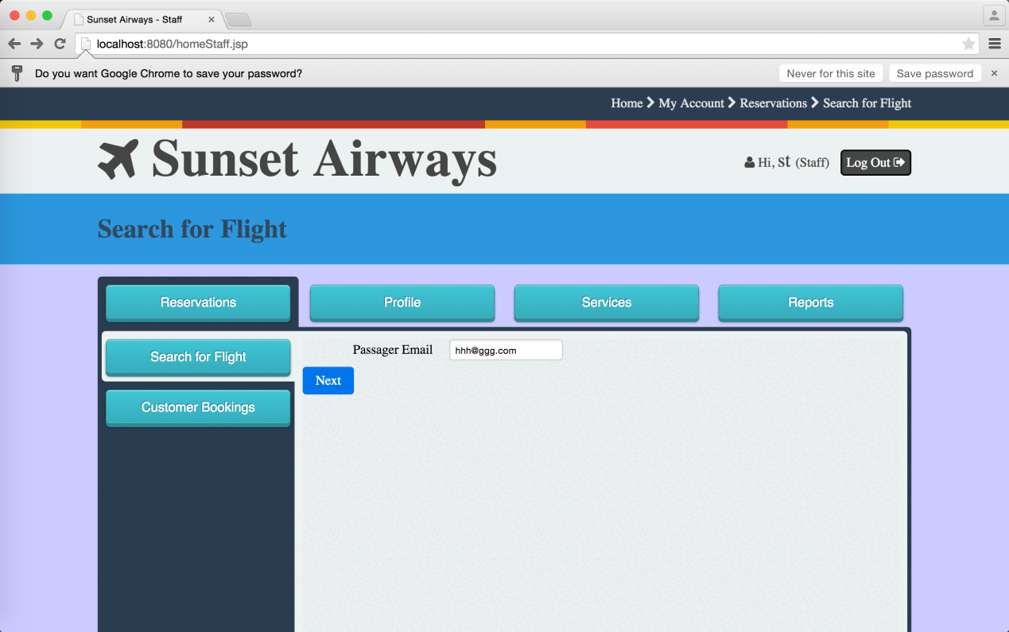

* 1. Agency can also make flight booking by provide the email of the member customer.

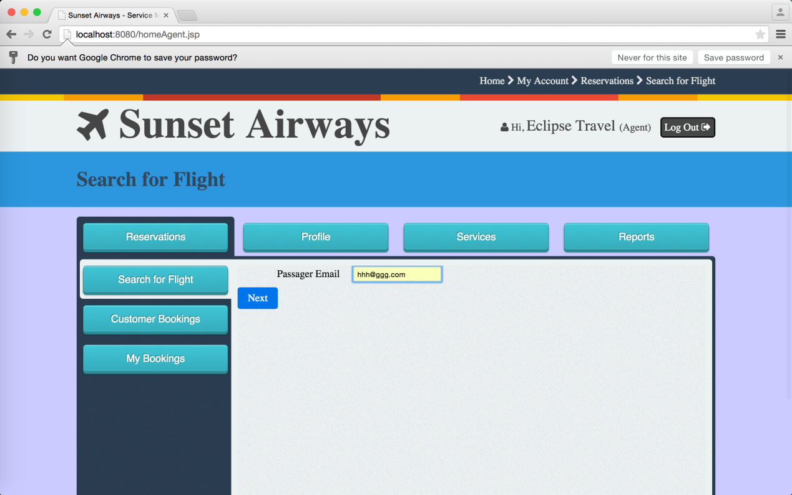

* 1. Customer can view owned flight bookings

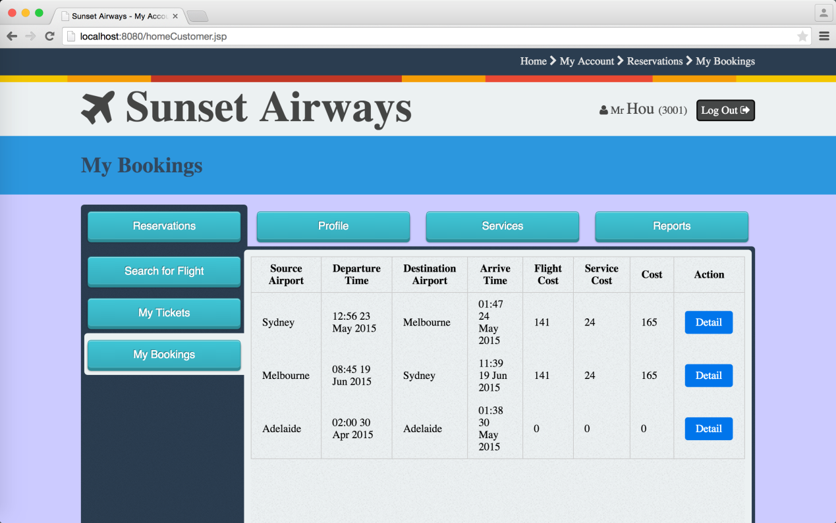

* 1. Customer can change the seat or change the flight

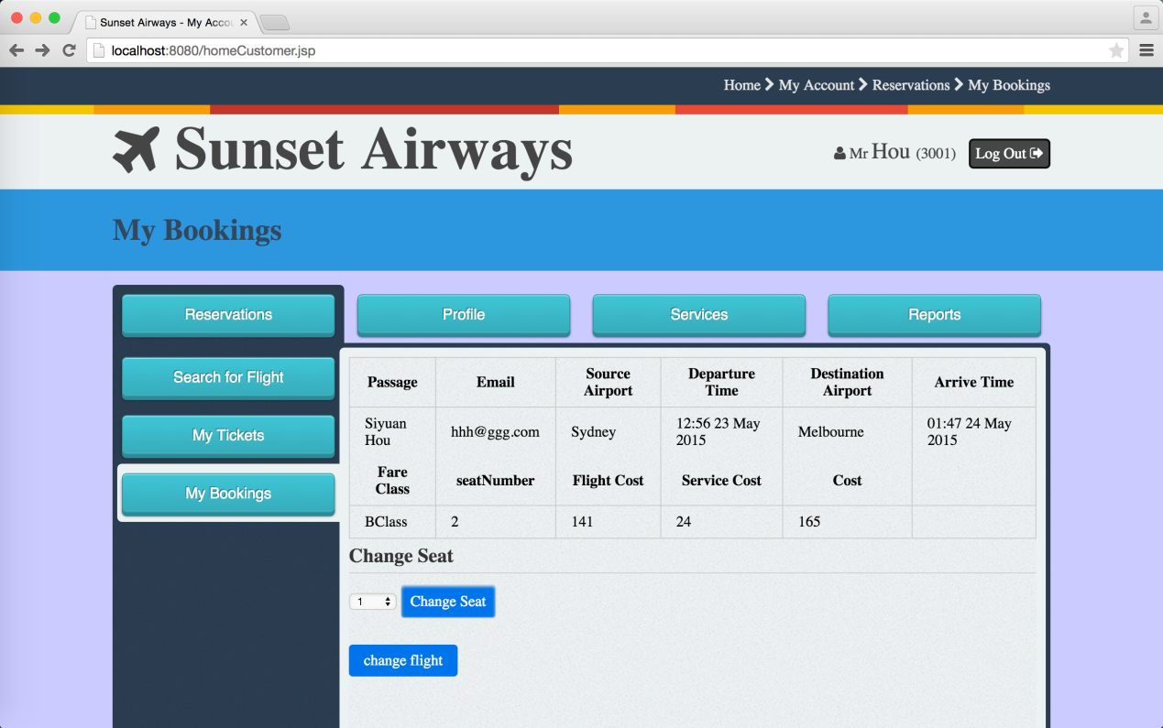

* 1. Staff and Agency can also do this for the customer by provide the email of the customer

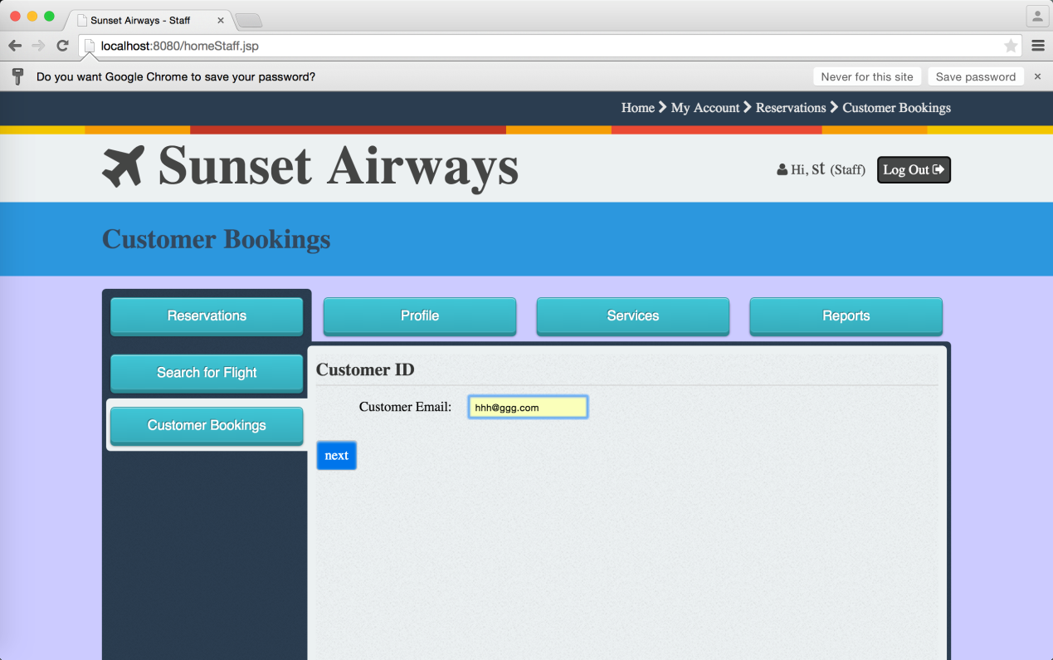

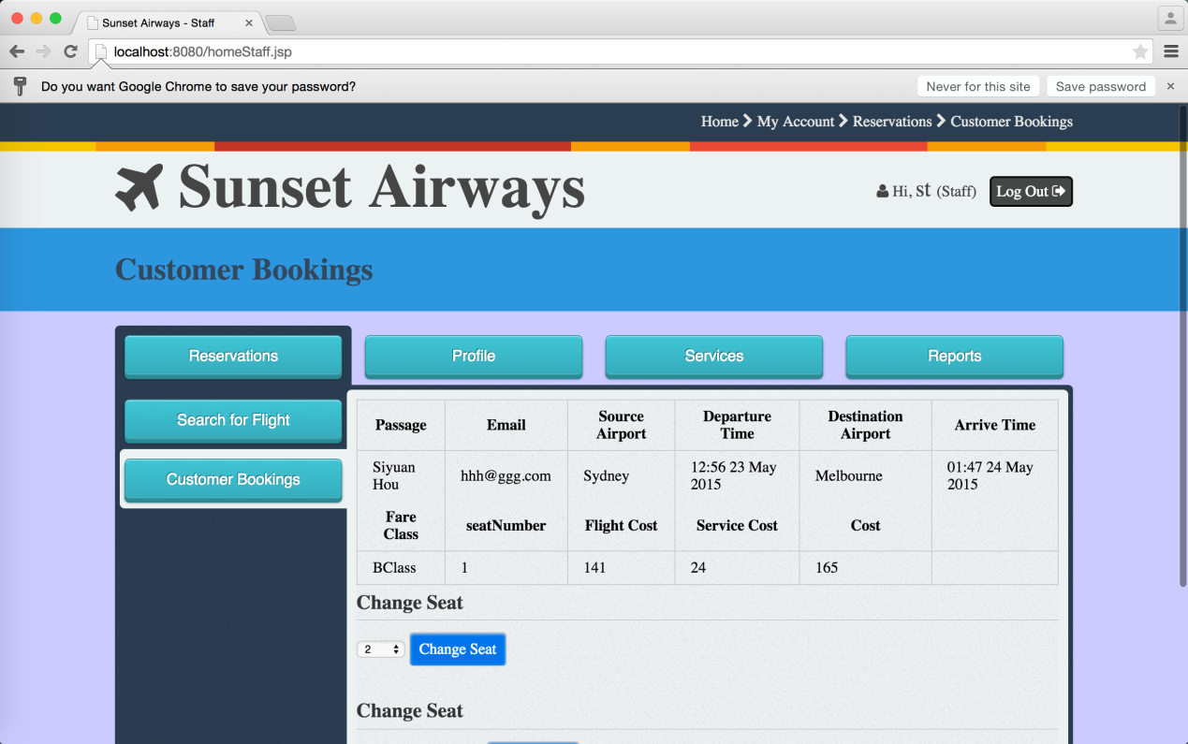

* 1. Staff can switch seats between two exited customer in the same flight

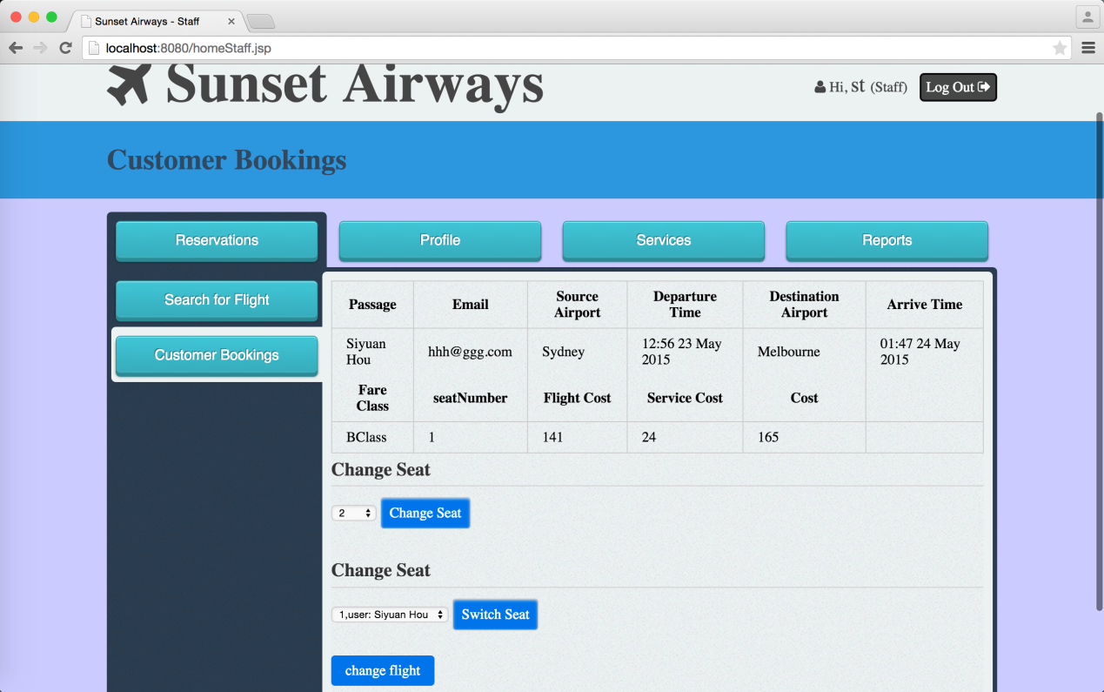

1. Profile Subsystem Functionalities

This section captures the functionalities that the Flight Management System provides to all users (System Admin, Flight Manager, Service Manager, Staff, Registered- customer, Unregistered-customer, Agency) manages not only individual passengers and travel agency profiles, but also the profile of the company employee (System Admin, Manager, Staff).

4.1 All system users can change user name or password

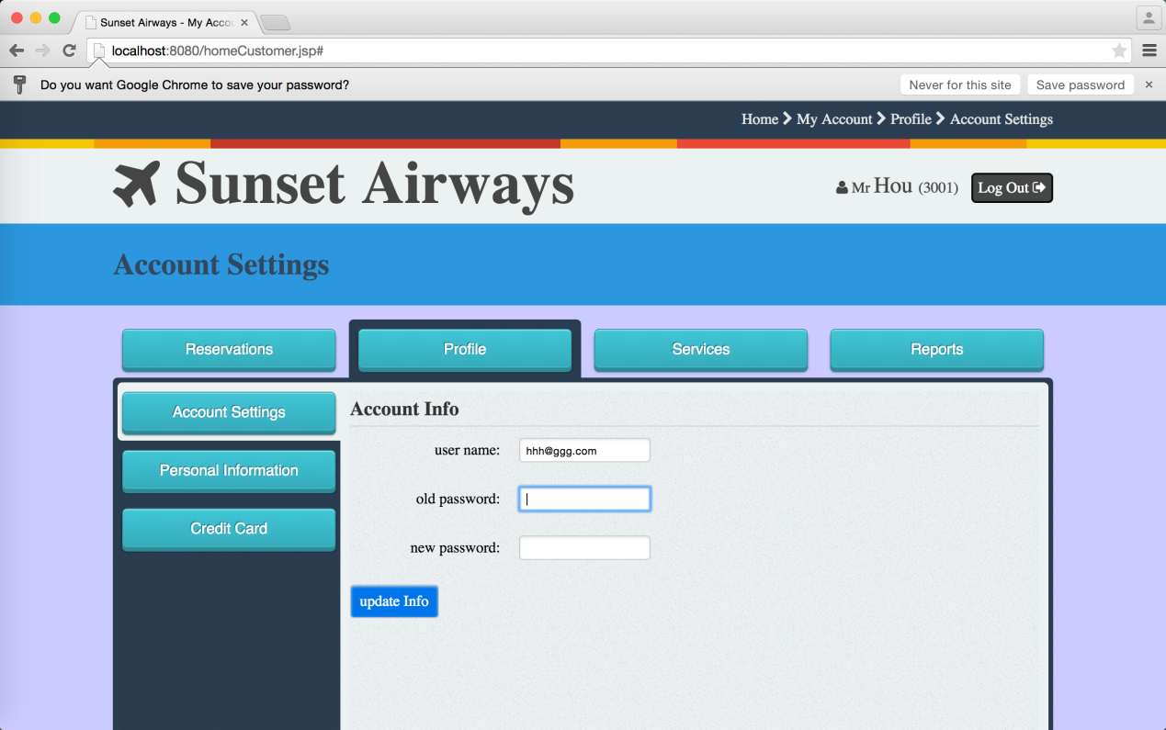

* 1. System Admin can create a new staff user by choose the authority, input user name and password.

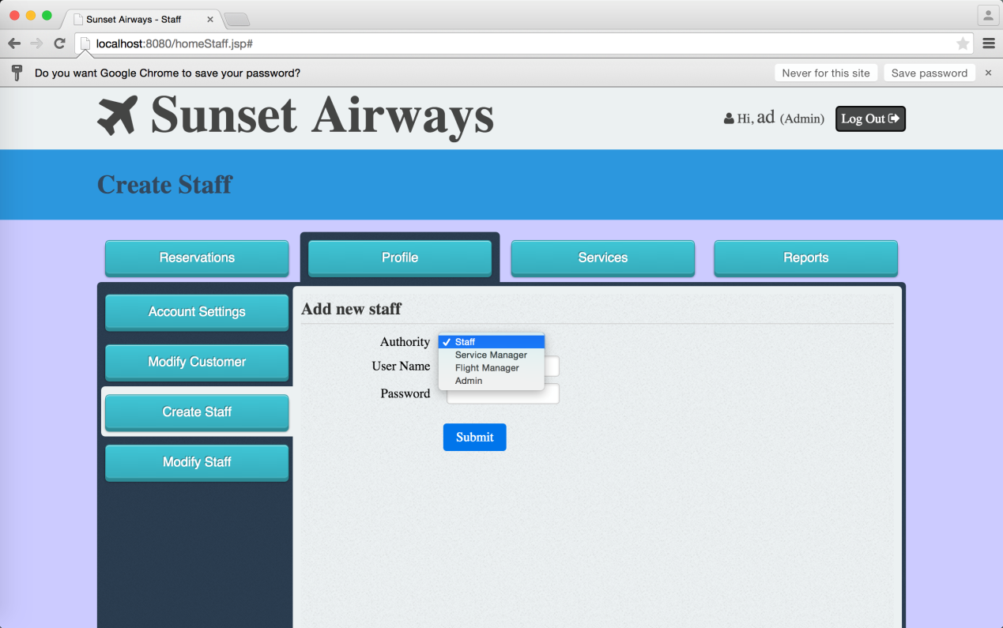

* 1. System Admin can modify and existed staff user by provide the user name

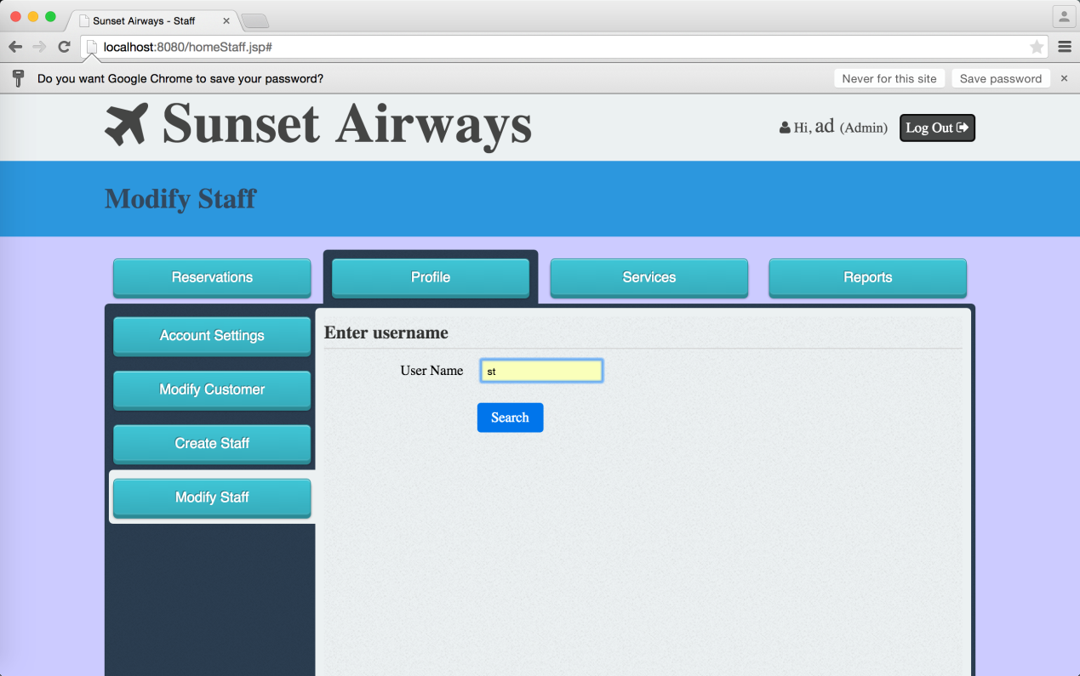

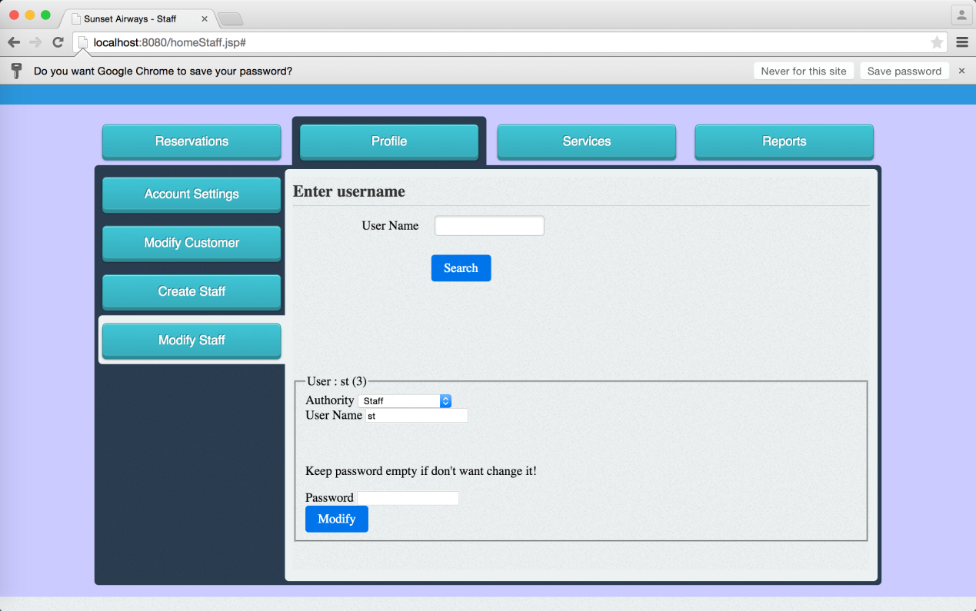

* 1. Staff can modify customer details by provide email

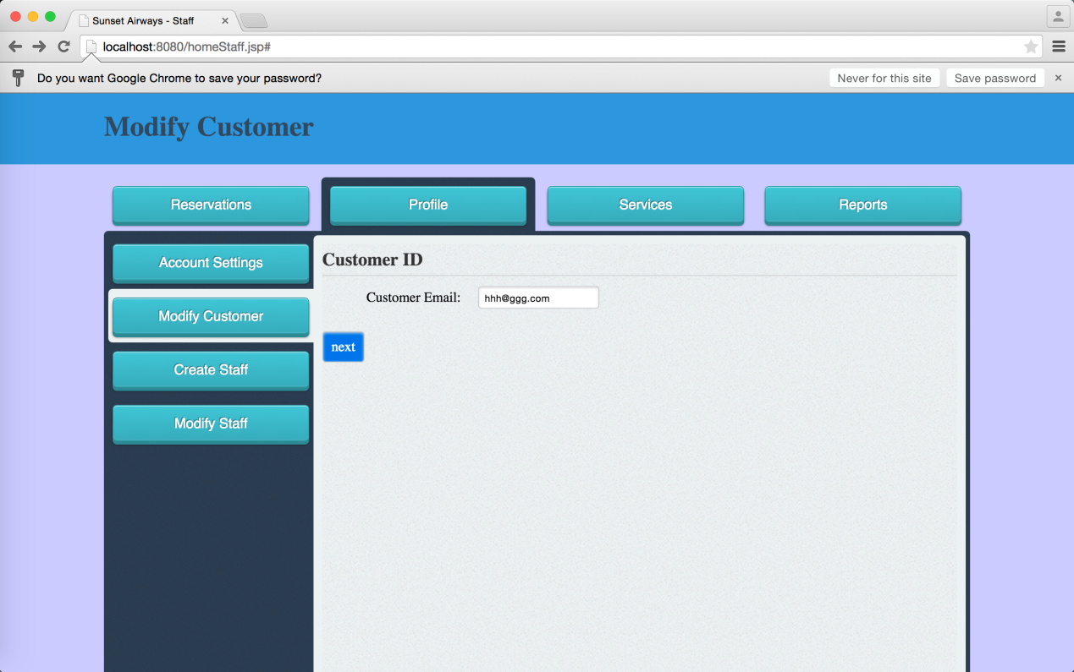

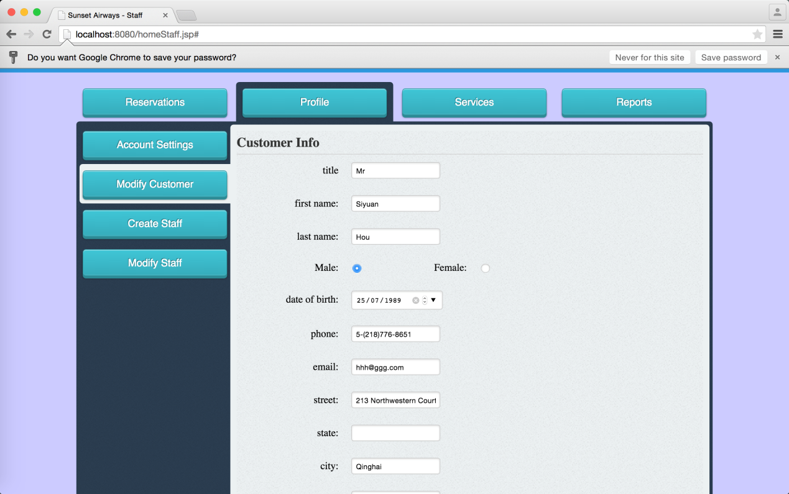

* 1. Agency can modify business information

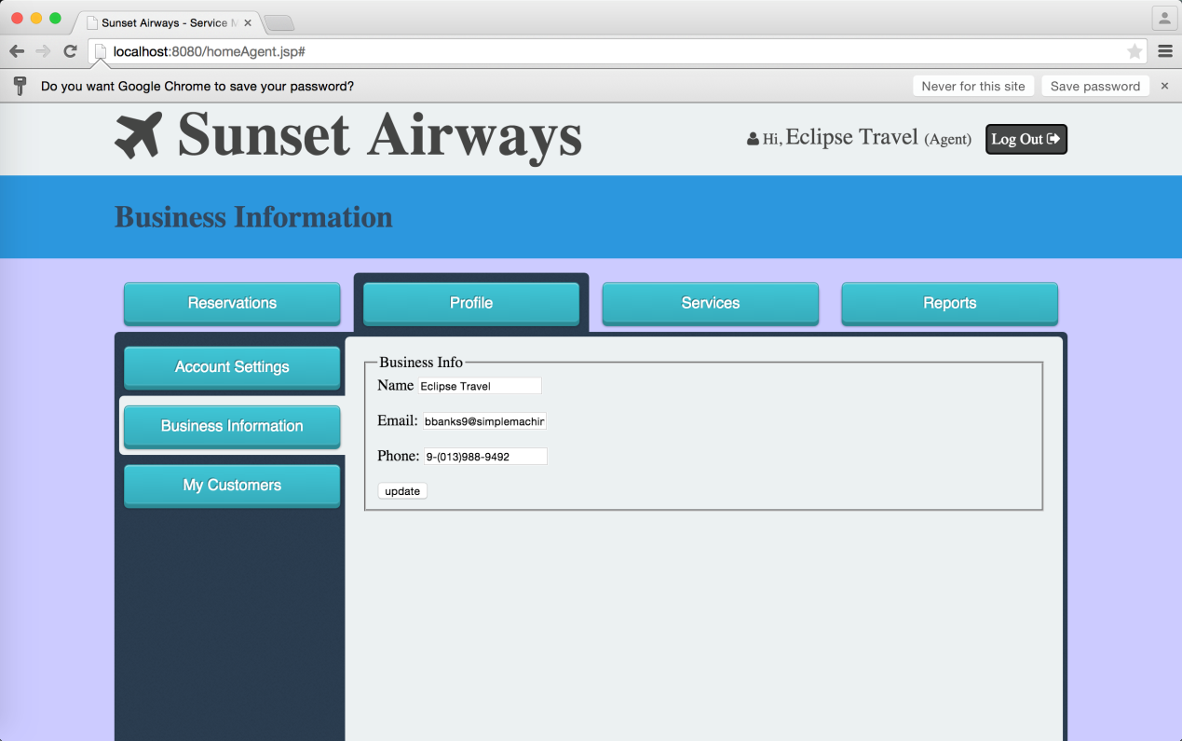

* 1. Agency can add customer as their member

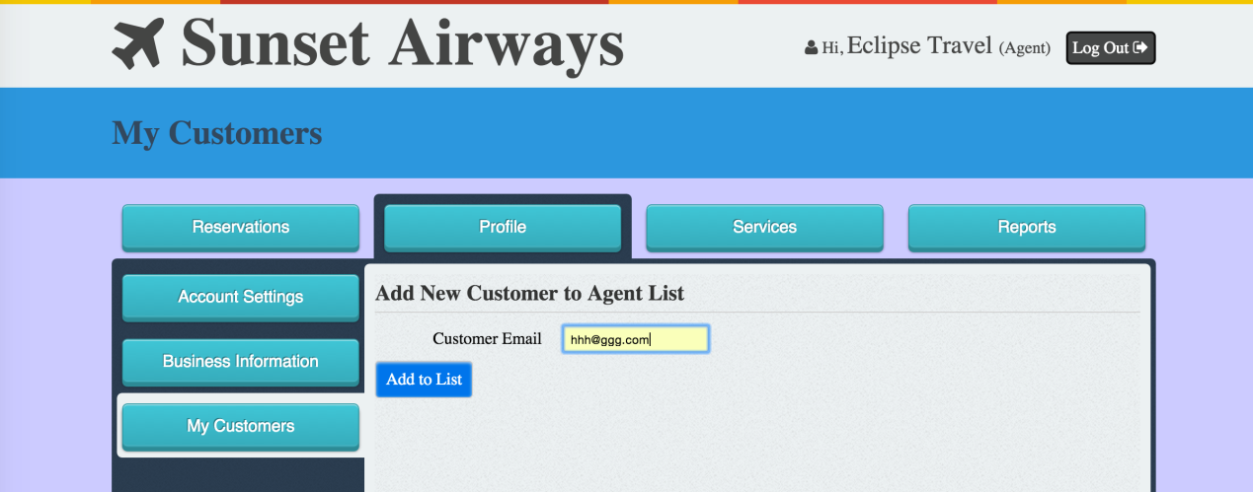

* 1. Agency can remove member customer

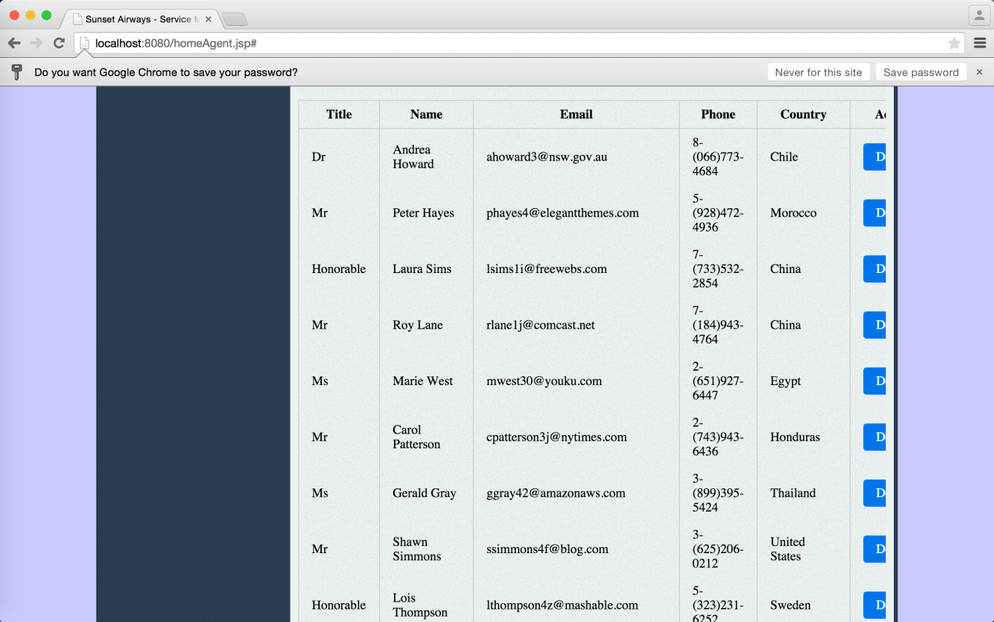

* 1. Customer can modify personal details

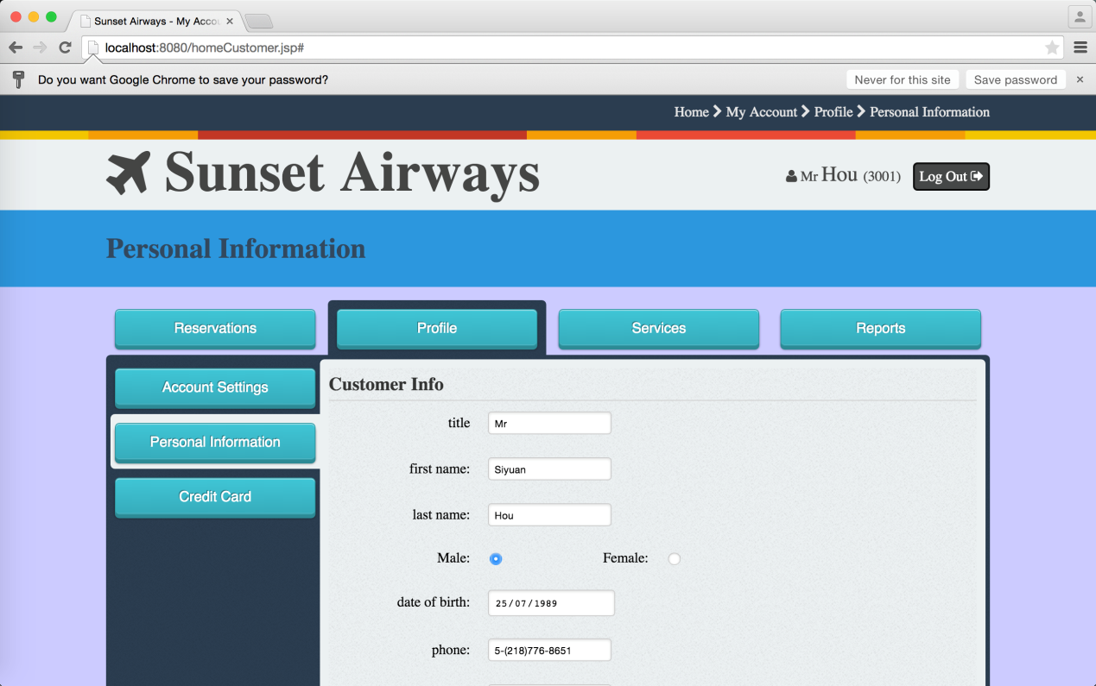

* 1. Customer can modify credit card details

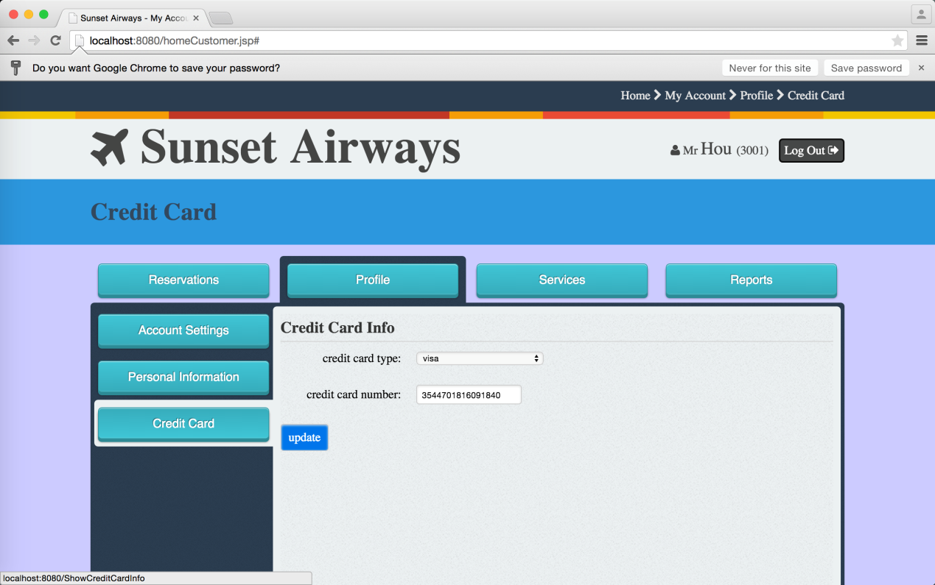

1. Service Subsystem Functionalities

This section captures the functionalities that the Flight Management System provides to all users (System Admin, Flight Manager, Service Manager, Staff, Registered- customer, Unregistered-customer, Agency) manages (e.g. add, edit, delete) all in-flight services such as food and drinks.

5.1 All system users can view all the in-flight services.

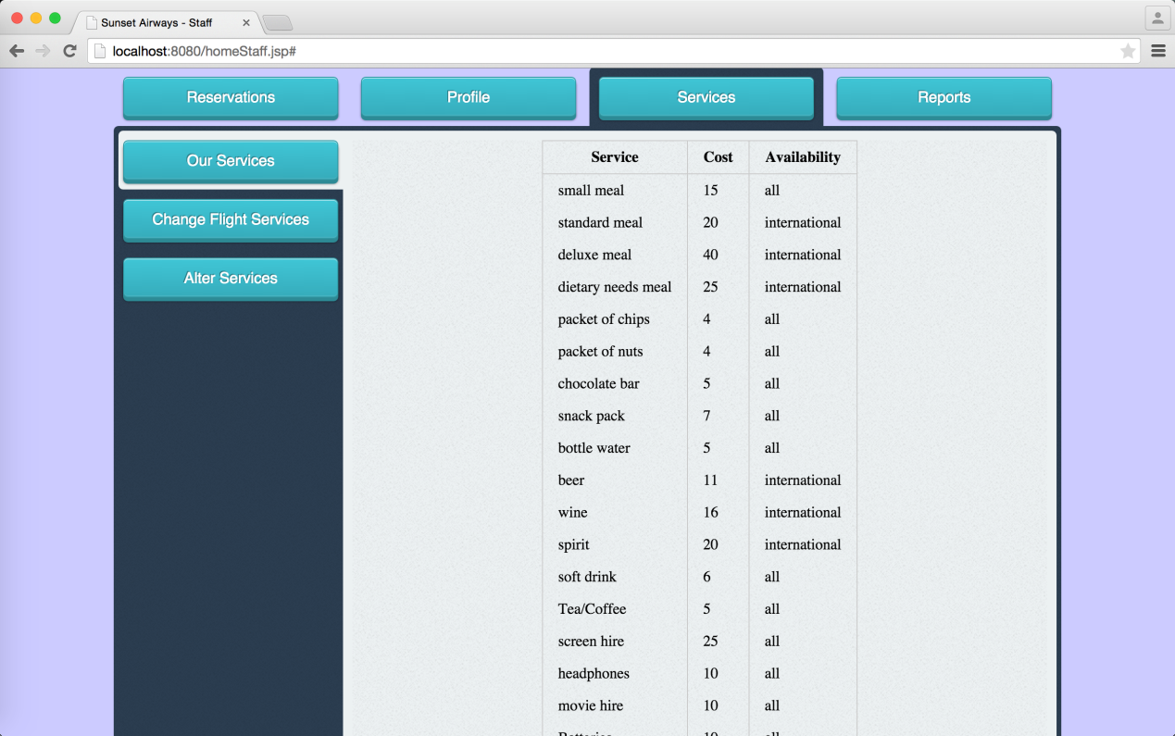

* 1. Service Manager can add, edit, delete in-flight services

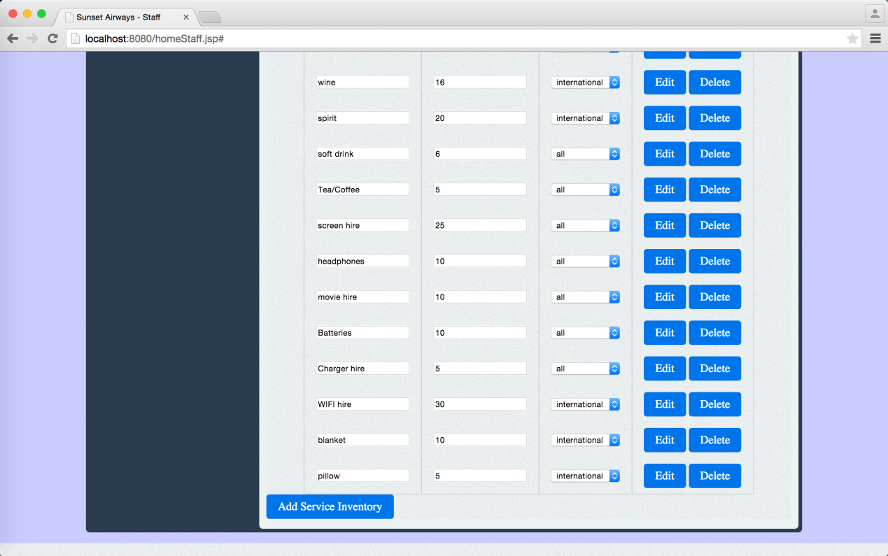

* 1. Customer can add/remove in-flight services in the flight booking

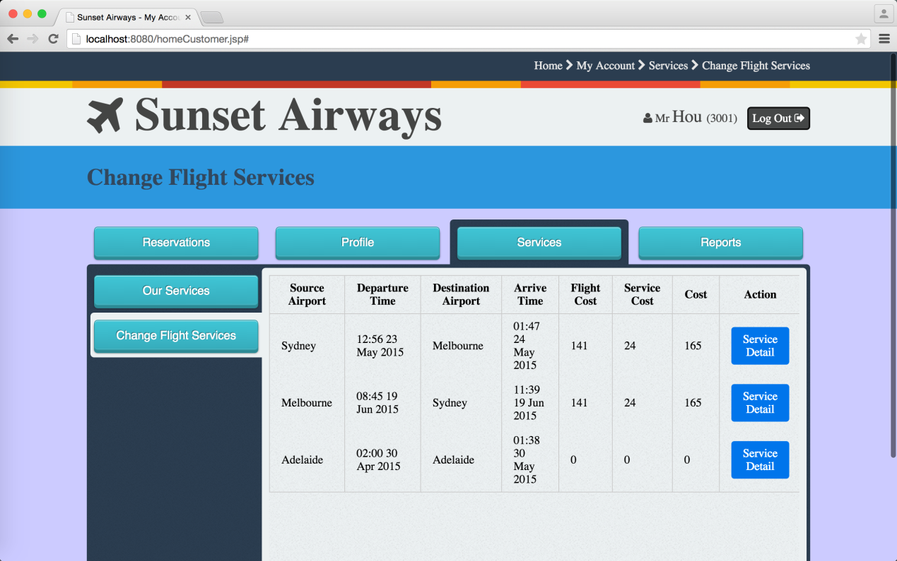

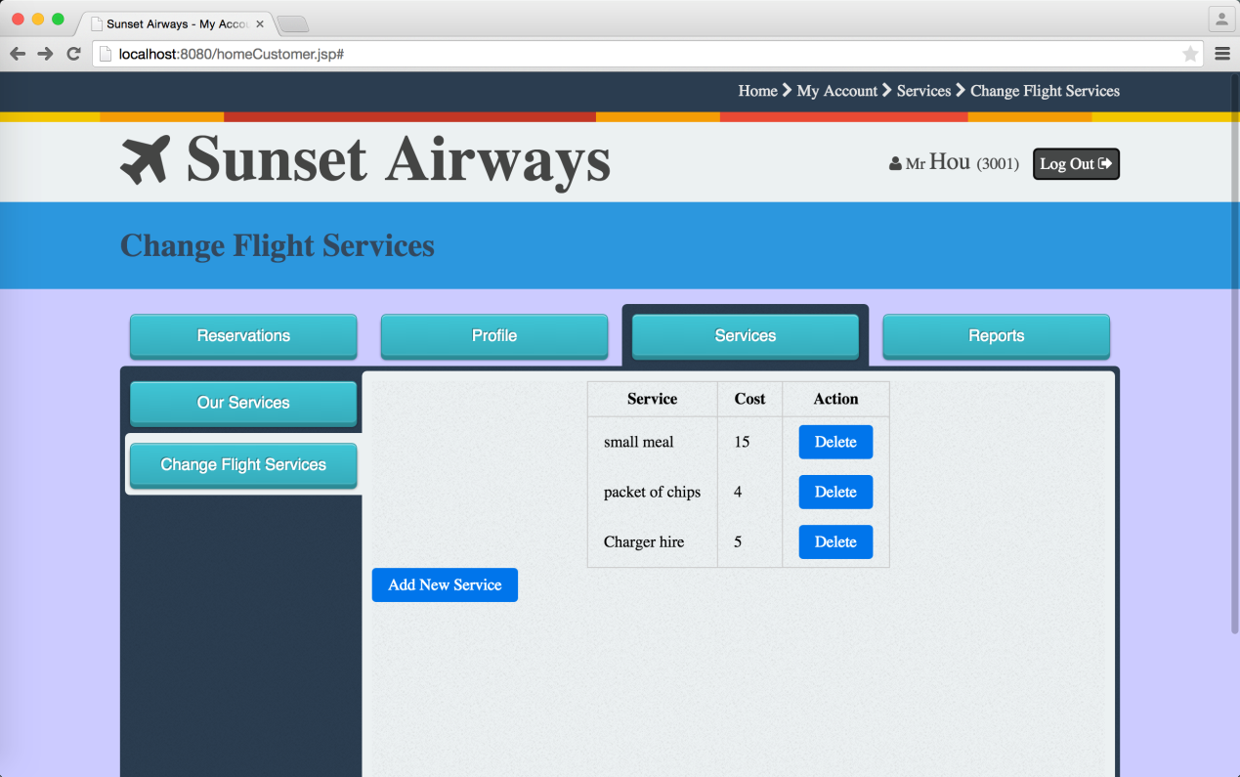

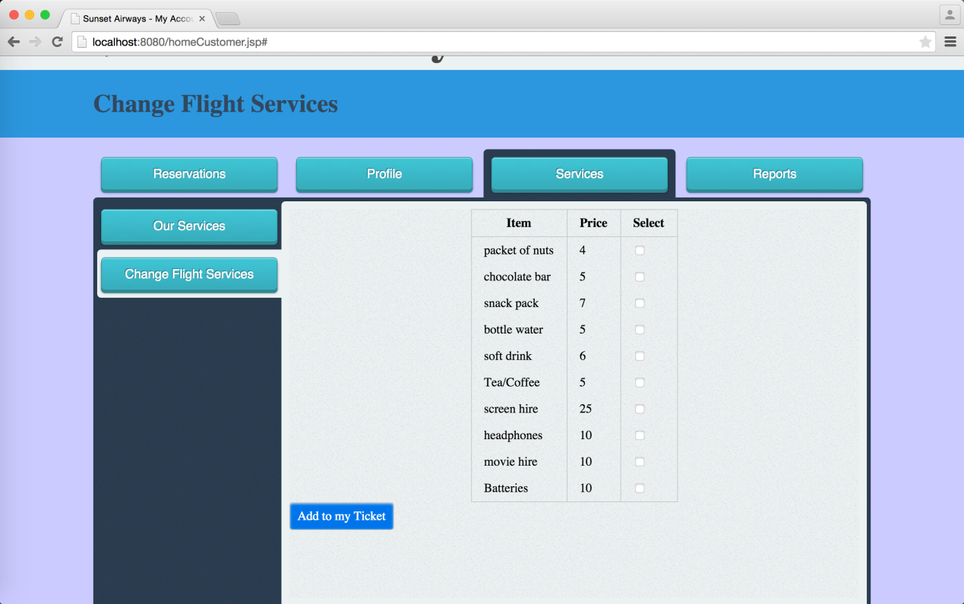

* 1. Staff and Agency can also help customer to add/remove in-flight service in a flight booking

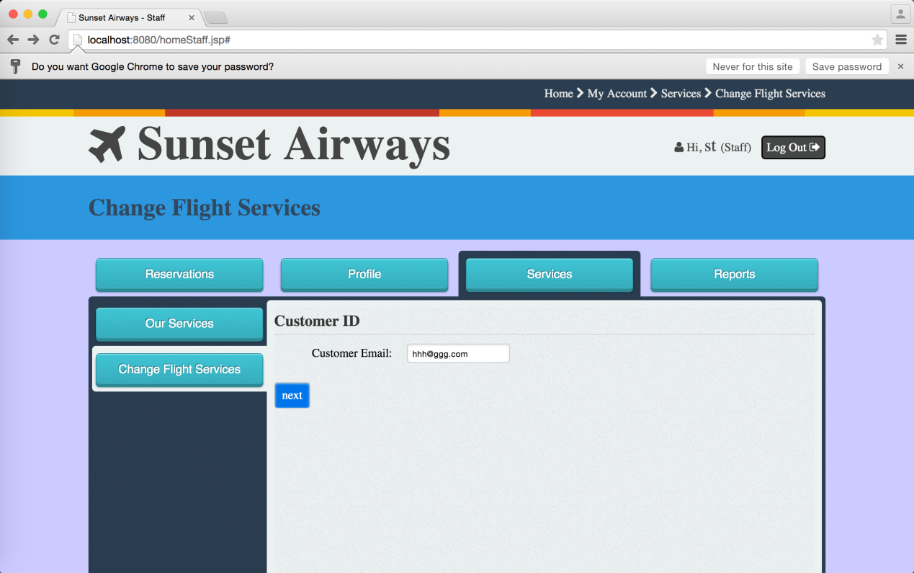

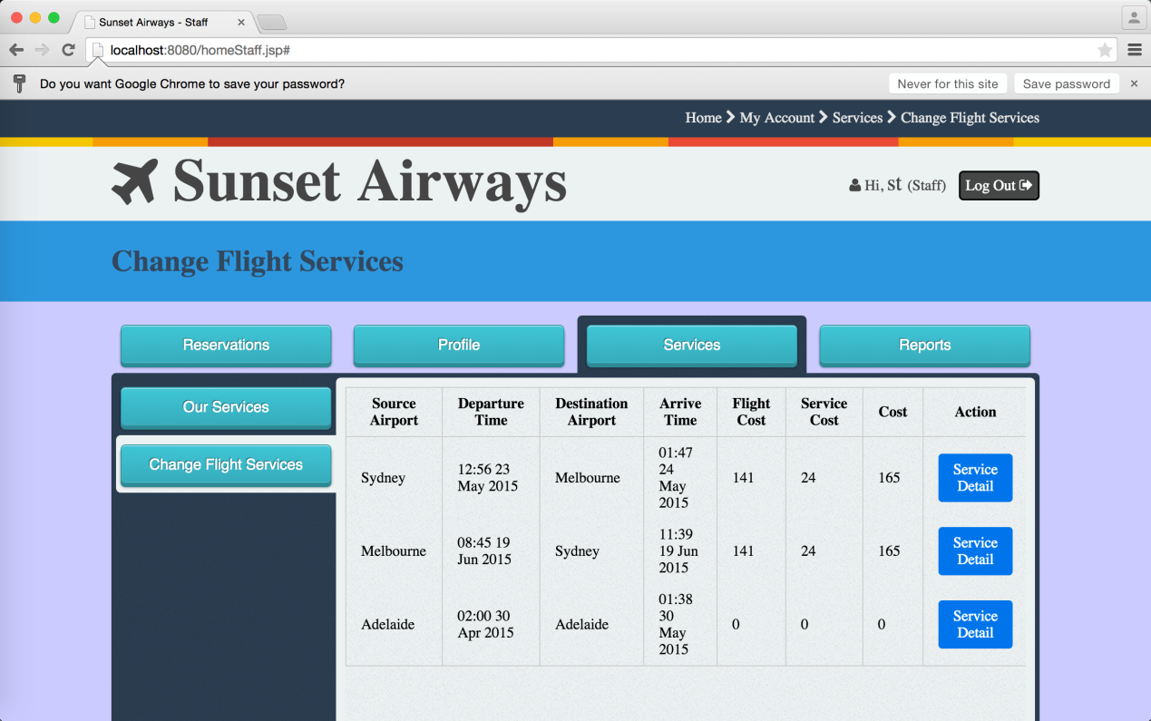

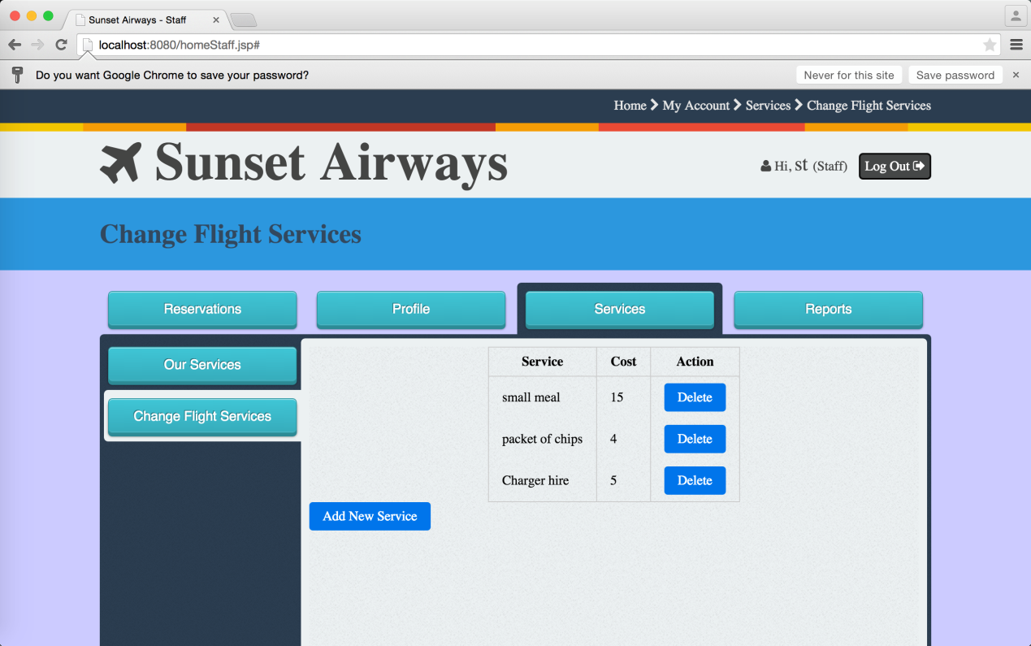

1. Report Subsystem

This section captures the functionalities that the Flight Management System provides to all users (System Admin, Flight Manager, Service Manager, Staff, Registered- customer, Unregistered-customer, Agency) to generate various summary reports.

6.1 Customer can generate customer report.

* 1. Agency can generate agency report.
  2. Staff user can generate staff report